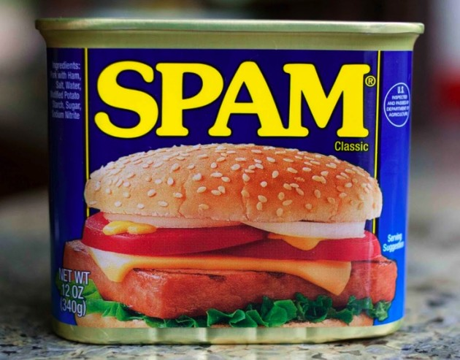

Who recognizes this?
Who has had this before?
Do you like it?
What is your favorite way to eat it?
Who dislikes it?
Anyone know some interesting facts about Spam? (used in WWII, especially popular in
Hawaii, is on McDonald’s menu in Guam, etc)
How is it made? What ingredients are used?
Situation—When and where? How will the context affect your speech—visual aids, movements, volume, etiquette, limitations, etc?

Purpose—Why? Why are you giving this speech? Why this topic or this focus? Why do you care that the audience listen to you speak on this topic? Why does this topic matter? This will help you write your speech better.

Audience—Who? Who is in your audience? What do they know? What do they think? What details and information would they find interesting? What evidence and examples would persuade them?

Method—How? How can you present the speech in a way that is relevant, interesting, persuasive, entertaining, inspirational, meaningful, etc. to the audience? What techniques can you use—verbal and nonverbal, visual aids, video, audio, pictures? What can you do to keep them engaged and listening?

If you think about SPAM before your speech, then it will be easier to prepare and you will have a more successful speech!

